**CHAPTER 1**

**INTRODUCTION**

* 1. **Overview of the Project**

The cornea is the outer layer of the eye, the surface covering the front of the eye. The structural and repair properties of the cornea are essential for its function such as protecting the inner contents of the eye, maintaining the shape of the eye, and achieving light refraction. The cornea is composed of proteins and cells, and does not contain blood vessels unlike most tissues in the human body. The existence of blood vessels may affect its transparency, which in turn may affect the proper light refraction, hence worsening vision. Because there are no blood vessels that supply nutrients in the cornea, tears and an aqueous liquid provide nutrients to the cornea.

Keratoconus is a noninflammatory condition characterized by progressive thinning, deformation, and scarring of the cornea. The pathological mechanisms of keratoconus have been investigated for a long time. Both the genetic and environmental factors have been associated with the disease, but in recent years, a new theory emerges that keratoconus.

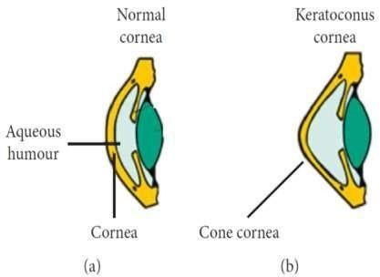

**Fig 1.1: Difference between a Normal Eye(a) and a Keratoconus Eye(b)**

At early stages the Symptoms of Keratoconus are similar to those any of Refractive Defect of eye so early detection of disease is hard. However, since many patients with allergies rub their eyes extremely, it has not been ascertained whether eye rubbing is a factor related to the keratoconus pathology but can increase the cornea deformation [2]. Imbalance of enzymes with in Cornea results in Weakening of corneal tissues which leads to Keratoconus. This imbalance makes more susceptible causing Cornea weakening and bulge forward.

In this Project, the image processing is performed first on the input corneal topography image in which it is subjected to pre-processing to remove noise, followed by image enhancement, segmentation and feature extraction. The output of the image processing is fed to a Machine Learning algorithm. Here, we have used a CNN model to train and validate the data images.

### Objectives

* + - * The main objective is to implement an algorithm that is able to determine whether an eye is affected or not by Keratoconus.
      * To efficiently train Corneal Topography images in CNN model.
      * To achieve maximum accuracy using Convolution Neural Network.
      * To integrate the model in the diagnostic process of an assistant software to help the ophthalmologist.

### Purpose

Keratoconus (KTC) is found in the general population with a ratio of 1 in 2000 persons; also, the incidence among children has increased significantly over the past few years. The number of people diagnosed with keratoconus is rising because more and more people are initially diagnosed when performing the screening for laser refracting surgery which includes an eye topography. Thus, the incidence of keratoconus in the population can be even greater. The epidemiological reports published in recent years show that in Russia only 0.3 cases per 100,000 people(0.0003%) are reported, in India 2.3% cases, in Israel 2.34%, and 2.5% in Iran. Usually, the illness debuts in the second decade of life and affects both sexes and all ethnicities. Keratoconus usually affects both eyes, however, one eye may be initially affected.

The main goal is to implement and test an algorithm that allows keratoconus detection by facilitating the diagnostic process. The most used modality to diagnose and confirm keratoconus is to make a corneal topography which is then interpreted by the ophthalmologist specialist. These images will consider the input of Kerato Detect algorithm, within the learning process associated with the convolutional neural network (CNN).

### Scope

The scope of our system is to help the ophthalmologists to maintain secure software for detect of Keratoconus disease at early stage itself. The system can extend to operate in every hospital for fast screening of patients and effectively reduce the burden of severity of loss of sight and corneal transplantation to overcome the disease which is not detected at early stage.

### Applicability

* + - The application can be deployed in the hospitals for Eye Care.
    - The application can also be used in institutions that carry out medical research.
    - This can be used in ophthalmology clinic that has the facility to develop topography images.
    - This application may serve as a base application which could be developed further to Identify and diagnose other eye conditions.